**Sprint 1 Deliverable (D1) Report**

**Title Page**

**Subject Name:** Software Engineering **Project Name:** Online Unused Medicine Donation System  
**Group Members:**

* Taha (Roll No: 23L-2644)
* Shahzeb (Roll No: 23L-2506)
* Ali Ahmad (Roll No: 23L-2619)

**Deliverable Number:** D1  
**Date of Submission:** [29-03-2025]

**1. Project Title and Introduction**

**Project Title: Online Unused Medicine Donation System**

**Introduction:**

The Online Unused Medicine Donation System is a web-based platform that facilitates the donation of unused medicines to NGOs and underprivileged individuals. It connects donors, NGOs, and healthcare providers, ensuring quality control and seamless distribution.

**2. User Stories**

**Sprint 1 User Stories**

**US1: User Registration**

**As a** donor/recipient, **I want** to register on the platform **so that** I can donate or request medicines.

**Sub User Stories:**

* US1.1: As a user, I want to enter my email and password to create an account.
* US1.2: As a user, I want to verify my email through a confirmation link.
* US1.3: As an admin, I want to approve user accounts for verification.

**US2: Medicine Listing**

**As a** donor, **I want** to list my unused medicines **so that** others can request them.

**Sub User Stories:**

* US2.1: As a donor, I want to enter medicine details (name, dosage, expiry date).
* US2.2: As an admin, I want to verify medicines before making them public.
* US2.3: As a recipient, I want to search and request medicines.

**3. Structured Specifications for User Stories**

| **User Story** | **Pre-condition** | **Main Flow** | **Post-condition** |
| --- | --- | --- | --- |
| **US1: User Registration** | User must provide valid credentials | 1. Enter details 2. Submit form 3. Verify email 4. Login | User account is created and verified |
| **US2: Medicine Listing** | User must be logged in | 1. Enter medicine details 2. Submit for verification 3. Admin approval | Medicine is available for request |

**4. Scrum Board (Trello Snapshots)**

**Snapshot 1: Initial Sprint Backlog Upload**

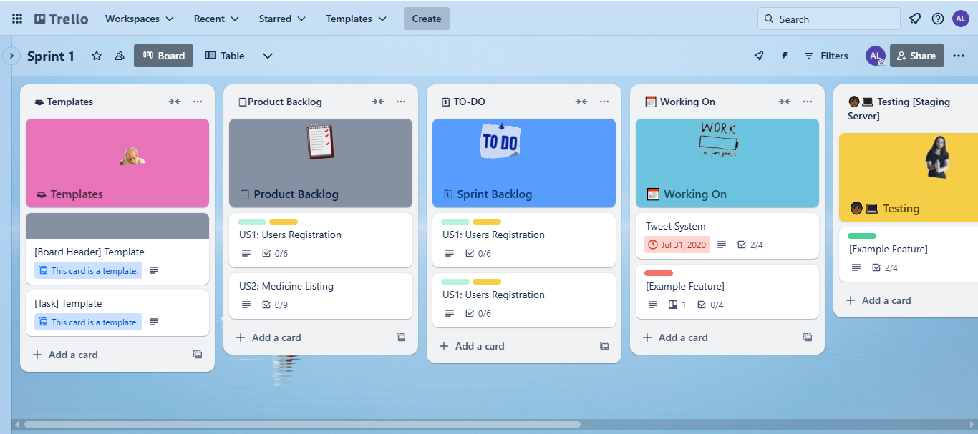

**Snapshot 2: Mid-Sprint Progress**

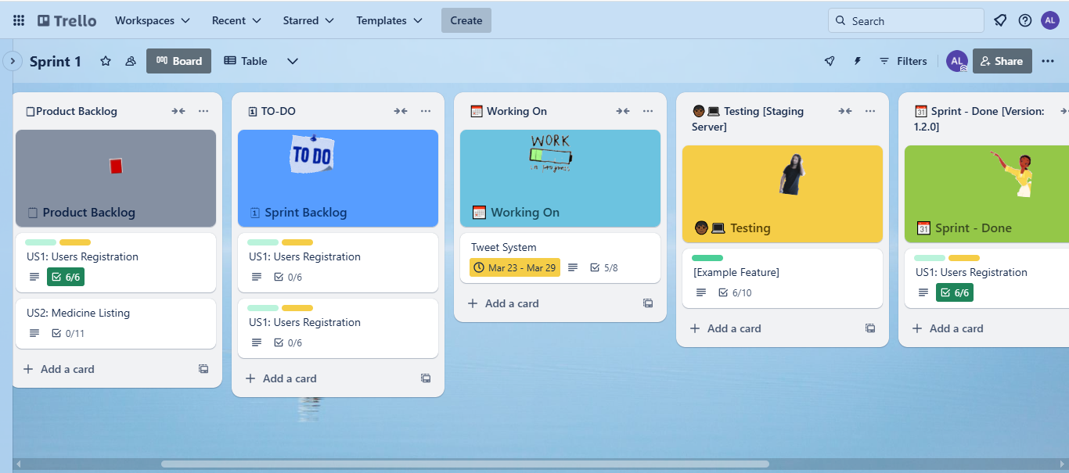

**Snapshot 3: Sprint Completion with Leftovers**

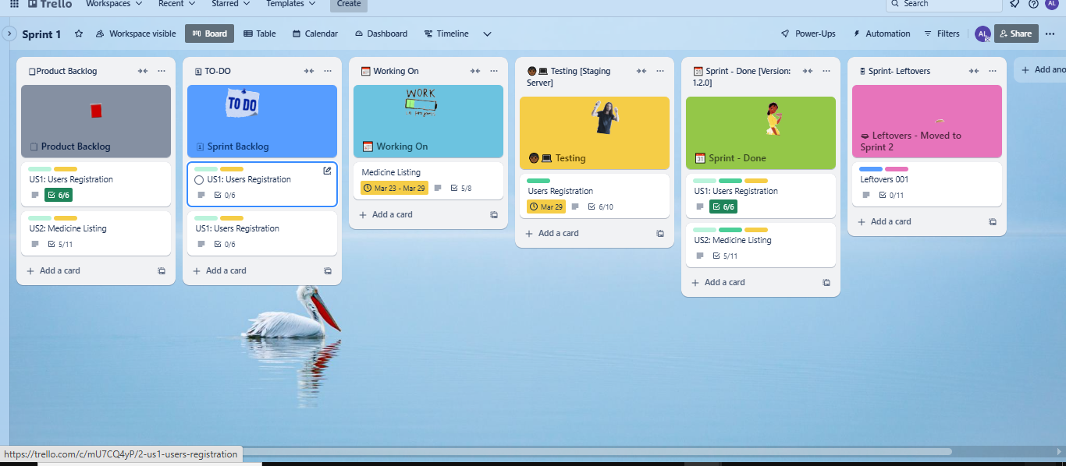

**5. Sprint 1 Burndown Chart**

A burndown chart is used to visualize sprint progress. The x-axis represents the sprint days, and the y-axis represents remaining tasks. Red Dashed Line → Ideal burndown (tasks completed at a steady rate). Blue Line with Dots → Actual burndown (shows progress trend).

* **Sprint Duration:** 10 days
* **Total Tasks at Start:** 20
* **Tasks Completed Per Day:** Approximate trend

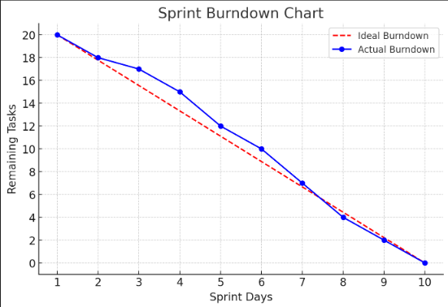

**6. NFR Specification (Natural Language Specification)**

| **NFR Category** | **Specification** |
| --- | --- |
| **Performance** | The system should support 100 concurrent users. |
| **Security** | User data must be encrypted and protected. |
| **Availability** | The system should have 99.9% uptime. |
| **Usability** | Users should be able to complete a donation within 3 minutes. |

**7. Iteration 1 Implementation Screenshots**

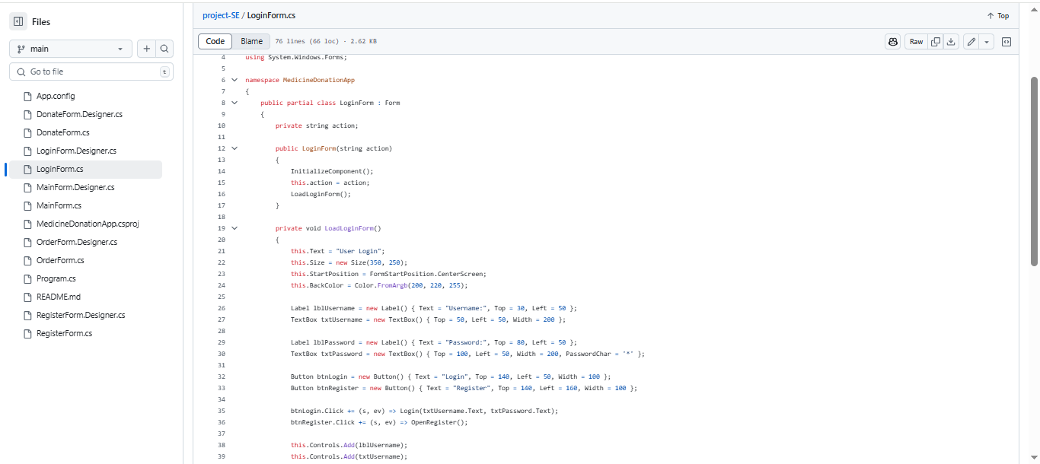

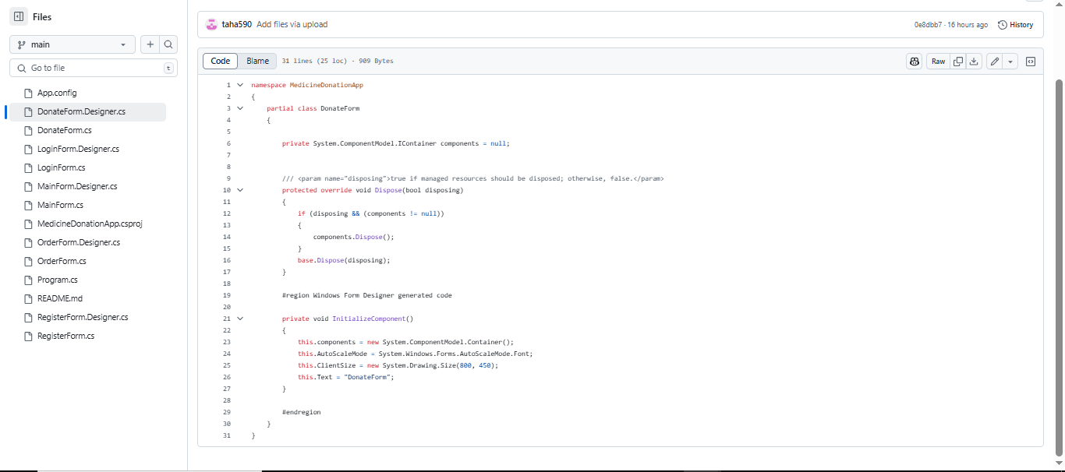

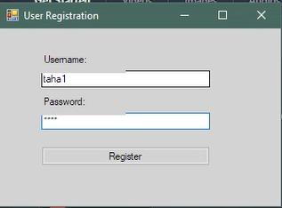

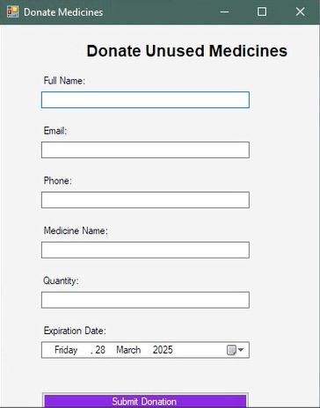

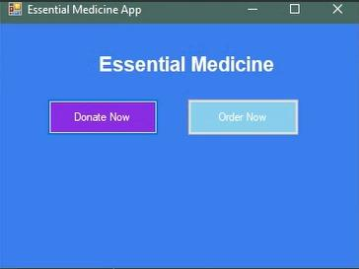

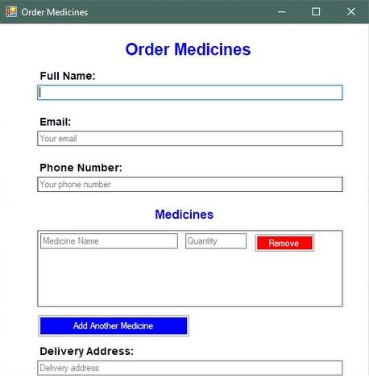

**8. Work Division**

| **Member** | **Role** | **Tasks Completed** |
| --- | --- | --- |
| Taha | Backend Developer | Implemented authentication API, database setup |
| Shahzeb | Frontend Developer | Developed login and registration UI |
| Ali Ahmad | QA & Testing | Performed unit and integration testing |

**Conclusion**

Sprint 1 focused on developing the user registration and medicine listing modules. Tasks were successfully implemented, and the remaining tasks are moved to Sprint 2.

**Next Steps:**

* Complete pending tasks from Sprint 1
* Implement medicine request and approval workflows
* Improve UI based on user feedback

**End of Report**